TMT/ Evita Technologies/S0501/2025 14.10.2025

To,
Evita Technologies,
Mobile: +91 70327 57478.

Dear Sir

SUB :- SUPPLY OF 80 MT HYDRAULIC PRESS

With reference to our discussions regarding your requirement for press. we are glad to inform you that, we are in a position to supply you the required equipment. The following are the specifications and our terms and conditions.

Specifications of the equipment

Technical Specifications :-

❖ Max Working Pressure - 250 Kg/cm2
❖ Normal Working Pressure - 200 Kg/cm2
❖ Design Pressure - 250 Kg/Cm2
❖ Tonnage at 200 Kg/cm2 - 80 Tons
❖ Cyl Bore - 240 mm
❖ Rod Dia - 100 mm
❖ Stroke - 80 mm
❖ Mtg - Front Flange
❖ Approach Speed - 16 mm/sec
❖ Pressing Speed - 0-5 mm/sec
❖ Return Speed - 25 mm/sec
❖ HP - 10 HP
❖ Tank Cap - 200 Ltr

Detail Bill of Material

❖ Cylinder Seals - Imported German Seals ( Merkel or Halite )
❖ Motor - ABB / Siemens / Kirloskar / Crompton
❖ Rod Seal - Imported halite Seal
❖ Valves - Yuken / Polyhydron / Hydrotech
❖ Check Valves - Polyhydron
❖ Hydraulic Pump - Yuken / Dowty
❖ High Pr Pump - Polyhydron
❖ Bell Housing - Micro
❖ Relief Valves - Polyhydron
❖ Hyd Tank - Micro
❖ Hyd Tank - MHPL
❖ Fitting - Hyloc / Hydair
❖ Gasket - Champion
❖ Fastners - TVS / LPS

Salient Features:
- TMT Hydraulic Iron Worker is designed to give an effective solution to all the cutting & punching problems of flat and Section with satisfactory work quality from robust and compact machine
- Unique compact design by using ultra-sonically tested steel plates
- Five work station catering '7' different operation
- International brands hydraulic & electrical components ensure trouble free operation
- Sequential operation of punching station with other work station
- Direct shearing avoids any waste of materials
- Hydraulic Holding Cylinder for Material Holding. (Shearing / Angle & Punching Station)

S No | Description of the unit | Offer
1. | Iron worker with 80ton capacity along with complete electrical and along with 10 hp motor | Rs 9,00,000/- (Rupees Nine Lakhs only)

GENERAL TERMS & CONDITIONS:

1. Price quoted per unit ex-work. Hyderabad.
- Following charges are additional to your account.
- Sales Tax : 18% GST
- Packing charge : As actual to be borne by you.
- Insurance : As actual to be borne by you.
- Payment : 50% advance along with order balance before delivery but after inspection at our works.
- Delivery :With 50% advance 2 months from date of advance received
- Validity : One month from the date of submission.
- Inspection : Inspection at our works prior to dispatch.
- Warranty : The machine is warranted for a period of 12 months from the date of dispatch against any manufacturing defects/ faulty material or bad workmanship of any part or component but not against any kind of abnormal or improper use of machine. Defective part or component will be replaced or repaired free of cost. Electrical components are outside the scope of this warranty.
- Commissioning : Erection & commissioning done by you, but required technical support & guidance provide by us at additional cost.

NOTE:
- Oil is not in scope of our supply.
- Raw material for trial is to be arranged by you at your cost.

We are sure you will find our offer in line with your requirements. Should you require any further clarification please contact 9246221106

Thanking you and assuring you of our best services

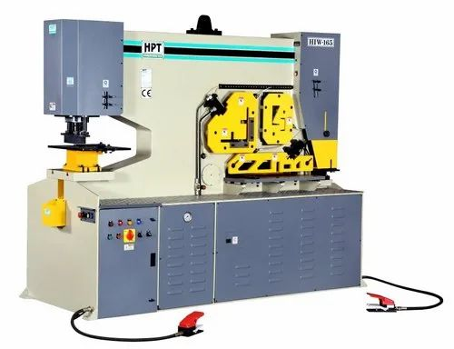

For TECHNO MACHINE TOOLS

( T. SIVARAMAKRISHNA)

